Title: Using Django to send emails to the users to enhance the register system.

The module which is set by Django called Django.core.mail can achieve the function of sending emails. First, we choose the QQ postbox as the SMTP server, and we start the POP3/SMTP service manually.

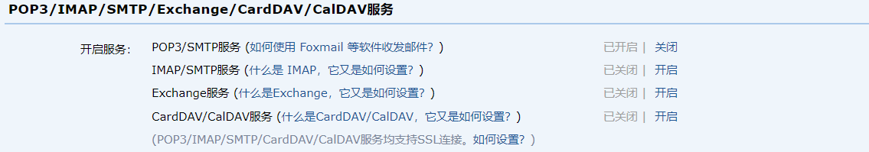

Then, we need to configure some information in the settings.py file.

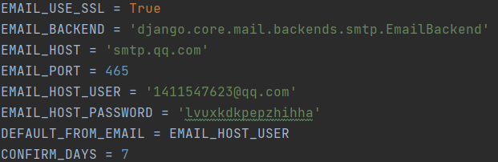

This is how we define the send_email function in the views.py file:

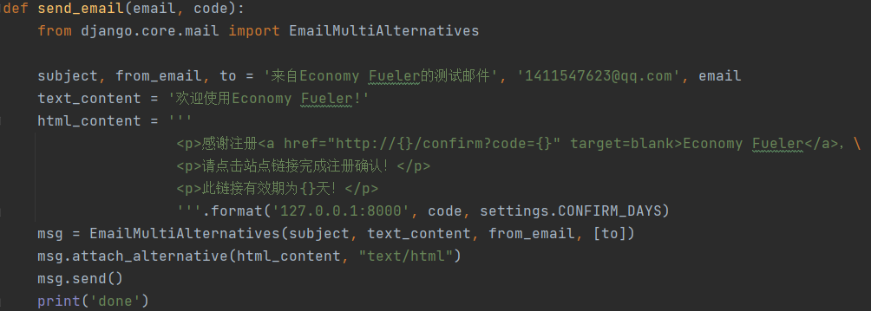

And this is how the email looks like:

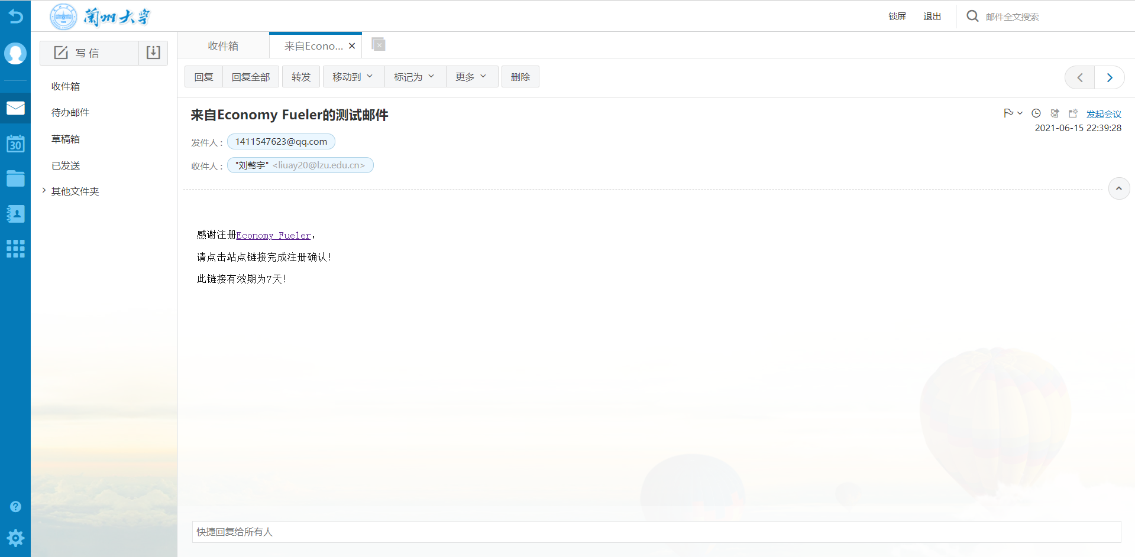

Once you clicked the link, you will be linked to the login page, for this is defined in the views.py file, and we also defined several warnings if the users operate unproperly:

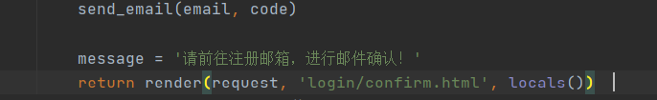



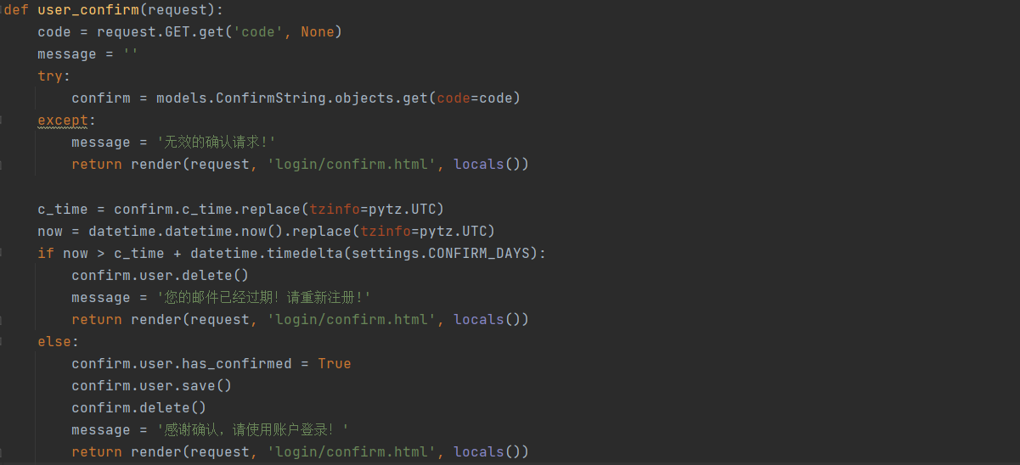

In the admin page, we can see the user’s information, including the user’s email address and whether the email address has confirmed:

